**Cyber Security Assignment**

**DAY 4**

Done by:

Athira Sabu

1)**Find out mail servers of following domain:**

**i)Ibm.com. ii)wipro.com**

Answer:i)Step 1:Open up kali.vmx file and login to the system.

Step 2:Take command prompt and type the following:

Nsookup

Ibm.com

Set type=mx

Ibm.com

Then we will get the mail servers of Ibm.com.The mail servers are:

mx0b-001b2d01.pphosted.com

mx0a-001b2d01.pphosted.com

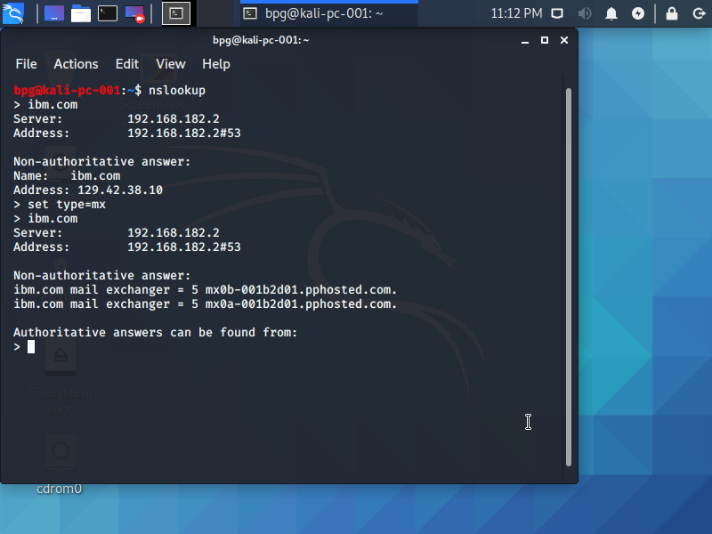

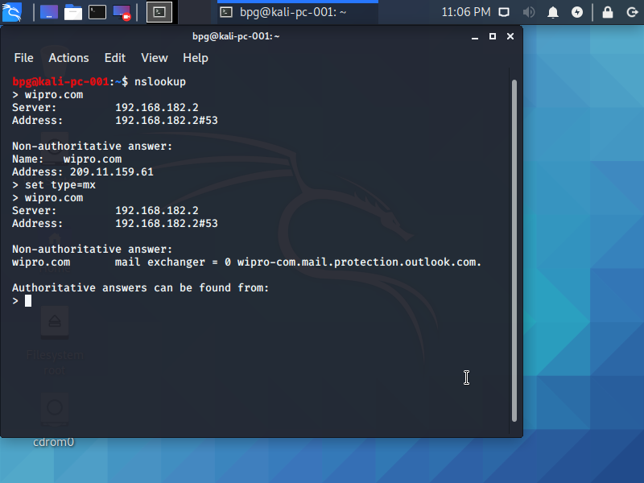

ii)Repeat the above process and open up command prompt in Kali and type the following:

nslookup

wipro.com

set type=mx

wipro.com

Then we will get the mail servers of wipro.com.The mail servers are

Wipro-com.mail.protection.outlook.com

2)**Find the locations, where these e-mail servers are hosted.**

Step 1:Go to google and search mail tracer.

Step 2:Open up and add the mail id of ibm.com and wipro.com separately and click on search. We will get the results separately.

The location of Ibm.com is Sunnyvale in United States and that of wipro.com is Singapore.

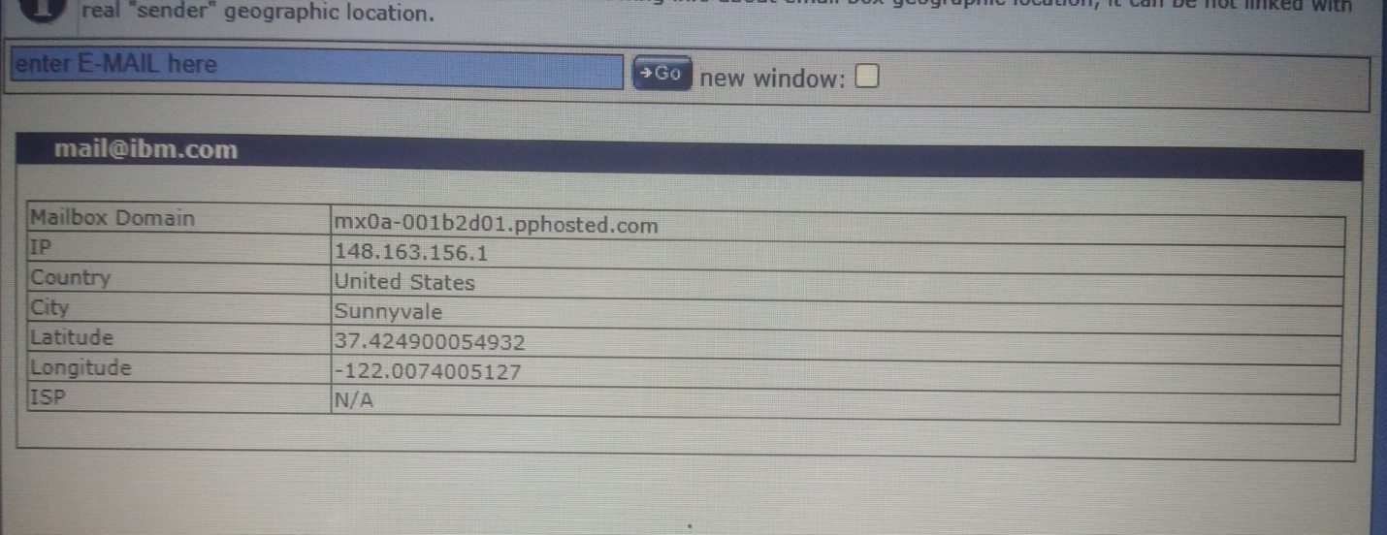

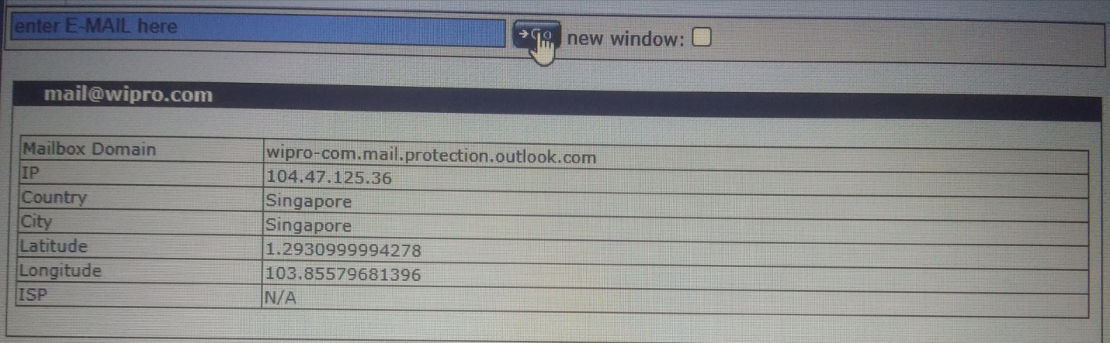

**3)Scan and find out port numbers open 203.163.246.23**

Step 1:Take Kali linux and type the following in command prompt:

sudo nmap 203.163.246.23

Then we will get the details of all open ports.

The open ports are:21/tcp

554/tcp

1723/tcp.

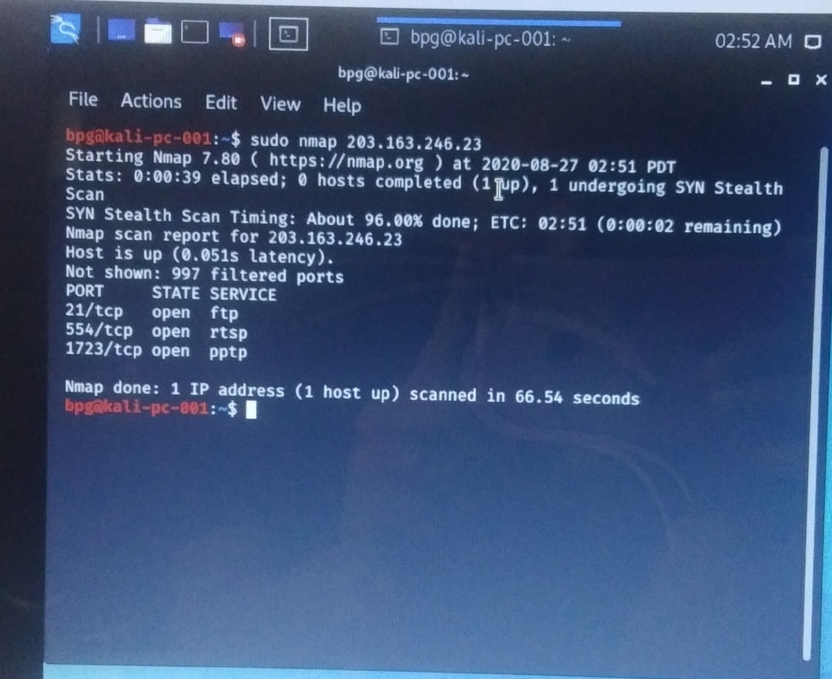

4)**Install nessus in a VM and scan your laptop/desktop for CVE.**

Step 1:Open up the browser in Kali and search for nessus download.

Step 2:Download nessus and open up and sign up.